TASK 05
- List all the main components you find inside a desktop PC after opening the cabinet, and write a short description (1-2 lines) for each.
1. Motherboard: The main circuit board that connects all computer components, such as the CPU, RAM, storage drives, and graphics card.
2. CPU (Central Processing Unit): The brain of the computer. It processes instructions and performs calculations to run programs.
3. RAM (Random Access Memory): Temporarily stores data and programs currently in use. More RAM helps the computer handle multiple tasks smoothly.
4. Storage Drive (HDD or SSD): Stores the operating system, software, documents, photos, and other files permanently
5. GPU (Graphics Processing Unit): Processes graphics and images for the monitor. It may be integrated into the CPU or installed as a separate graphics card.
6. SATA Data Cables: Connect compatible HDDs and SSDs to the motherboard for data transfer.
2. Take clear photos or draw labeled diagrams of each step as you disassemble a desktop PC, and organize them in a document with captions explaining what you did at each step.<br><br><em><strong>Hint:</strong> Include steps like unplugging power, removing side panel, disconnecting cables, and removing RAM, HDD/SSD, and motherboard.</em>.

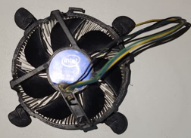
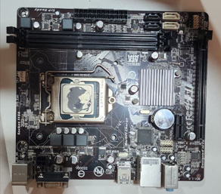
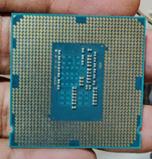
CPU cooler fan
CPU
Motherboard

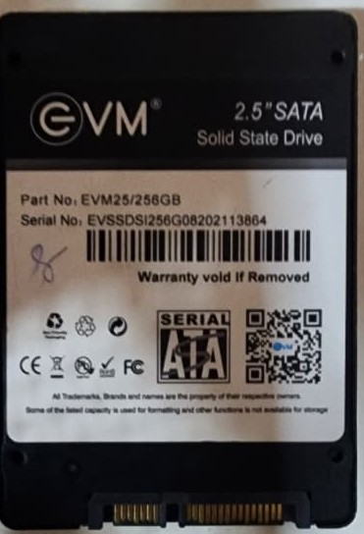
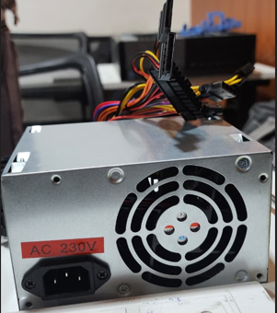
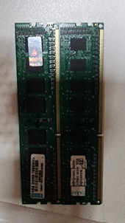

RAM
SMPS
SSD

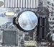

3. Reassemble the PC you disassembled, documenting each step with a brief explanation of what you connected or installed and why the order matters.
CMOS BETTERY
SMPS
Audio connector

USB connector
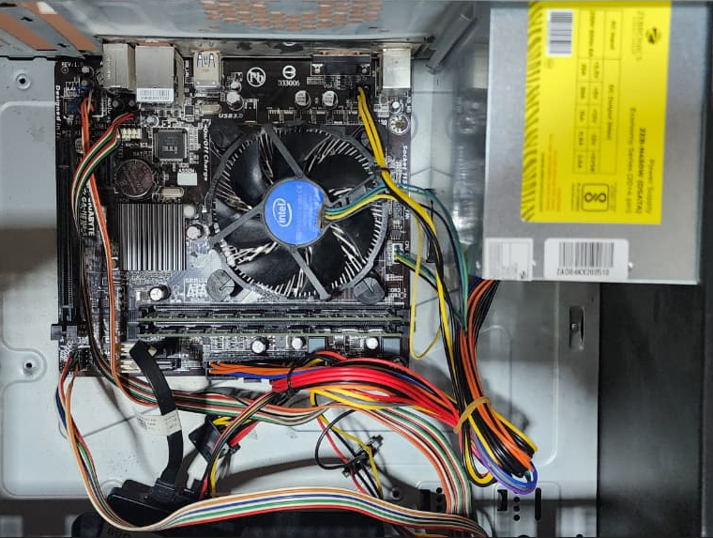
SSD
CPU fan connector
SMPS 24 pin connector
SSD SATA Cable
COMS battery
Motherboard
CPU cooling fan
RAM

4.Create a checklist of safety precautions and tools needed before starting the PC assembly/disassembly process, and explain why each is important.
Small screwdriver:
  - Used to loosen and tighten standard screws on the PC case, motherboard, and component mounts.
- Anti-static wrist strap:
  - Worn around your wrist and clipped to a grounded metal object to drain static electricity.
- Magnetic screw holder or small container:
  - Keeps tiny screws organized so you do not lose them or let them roll onto the motherboard.
- Tweezers or needle-nose pliers:
  - Helps you pick up dropped screws, jumpers, or small connectors in tight spaces.
- Smartphone or notepad:
  - Allows you to take reference photos of cable routings and header locations before unplugging them.
- Zip ties or Velcro straps:
  - Used for neat, safe cable management during reassembly.

